I have used the default buildin dataset of ‘MovieLens 100K Dataset’

from surprise import Dataset

Dataset.load_builtin("ml-100k")

MovieLens 100K movie ratings. Stable benchmark dataset. 100,000 ratings from 1000 users on 1700 movies. Released 4/1998.

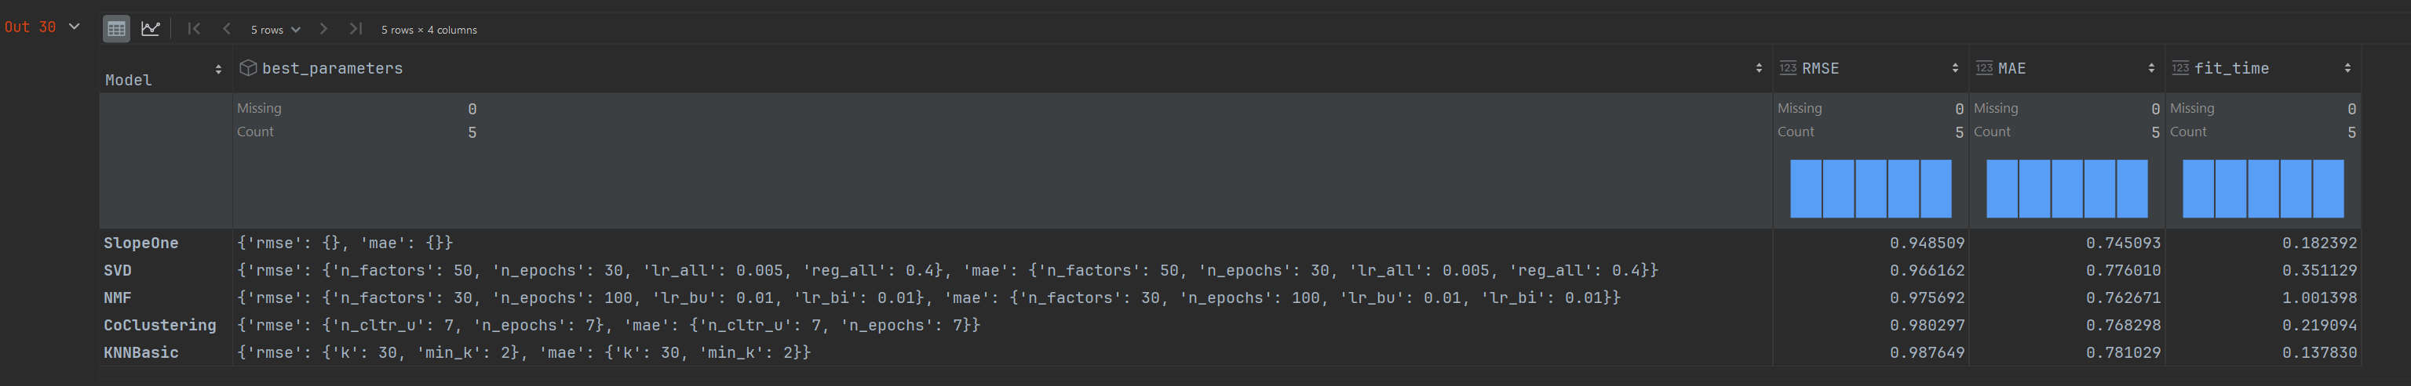

The above table shows the model with lowest error scores is the SlopeOne model with 94.8% RMSE and 74.5% MAE scores, also that model has the best ‘fit_time’ of 0.18 sec.

Low RMSE values show that the model makes more accurate predictions and fits the data well. In general, the lower the MAE, the better the model predicts. However, the relationship between MAE values and how good a model performs depends on the data.

The NMF model has the longest run-time with 1 sec ‘fit_time’.

The worst performer with highest error scores is KNNBasic model with 98.7% RMSE and 78% MAE.

Higher scores, imply more significant mistakes and fewer accurate forecasts.